**KO: Query data using Spark SQL**

Step 1: Import the required packages in Scala and create the table for Spark SQL:

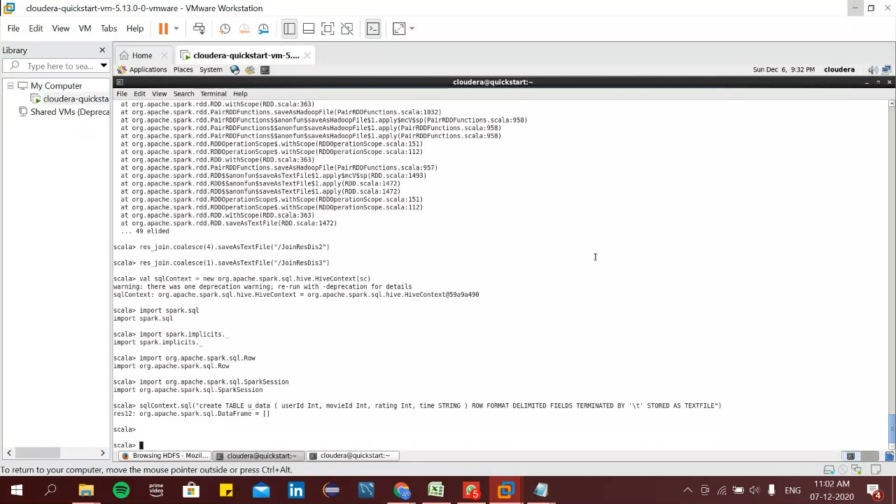

Here we uploaded the required packages and made a table for the Spark SQL.

Required packages:

val sqlContext = new org.apache.spark.sql.hive.HiveContext(sc)

import spark.sql

import spark.implicits._

import org.apache.spark.sql.Row

import org.apache.spark.sql.SparkSession

sqlContext.sql("create TABLE u_data ( userId Int, movieId Int, rating Int, time STRING ) ROW FORMAT DELIMITED FIELDS TERMINATED BY '\t' STORED AS TEXTFILE")

Step 2: Loading data to the table:

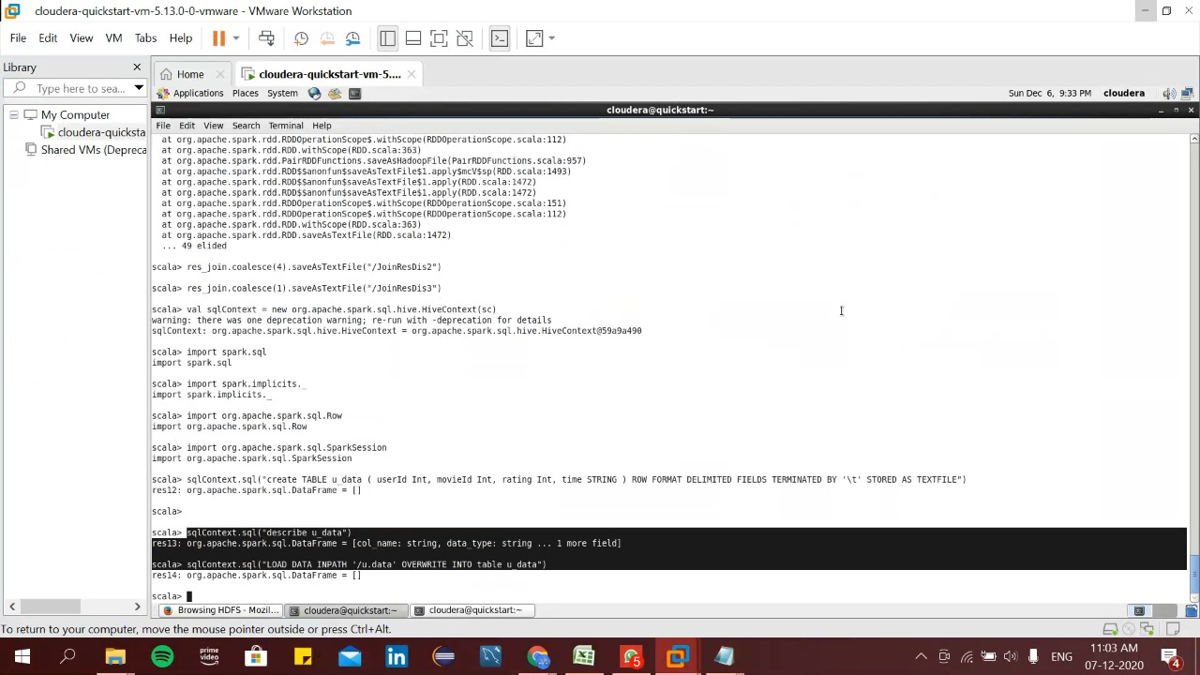

Step 4: We described the structure of the table using:

sqlContext.sql("describe u_data")

Step5: Here we uploaded data to the table created using:

sqlContext.sql("LOAD DATA INPATH '/u.data' OVERWRITE INTO table u_data")

Step 6: Displaying the first 10 rows:

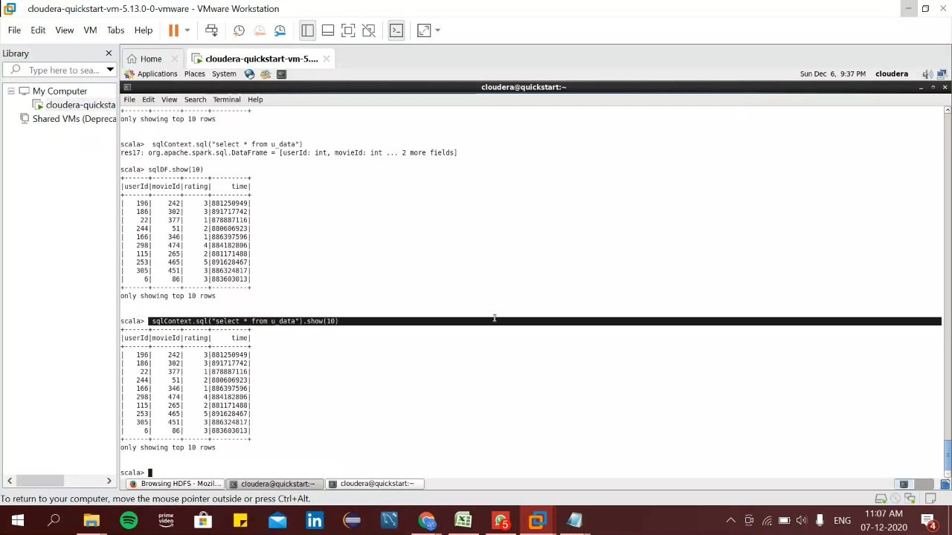

Step 7: Printing the first 10 rows of the table:

val sqlDF = sql("select * from u_data").show(10)

//This command will print the 10 rows of the table.

Step 8: We can also use the command to print the 10 rows:

sqlDF.show(10)

Step 9: Creating a view and Grouping:

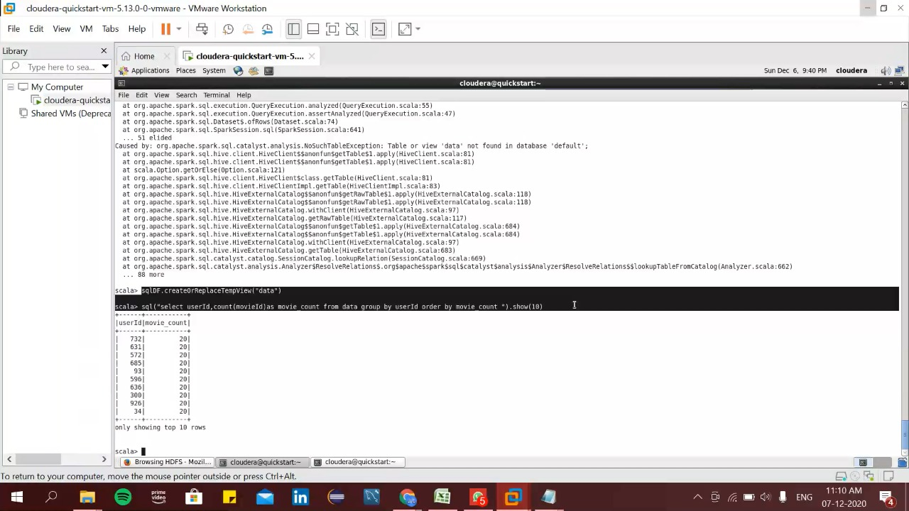

Here we have created the temporary view of the table to do SQL operations on the data.

sqlDF.createOrReplaceTempView(“data”)

then we have done SQL query for counting how many movie has been watched by each user

sql("select userId, count(movieId) as movie_count from data group by userId order by movie_count ").show(10)

Grouping based on Movie_id:

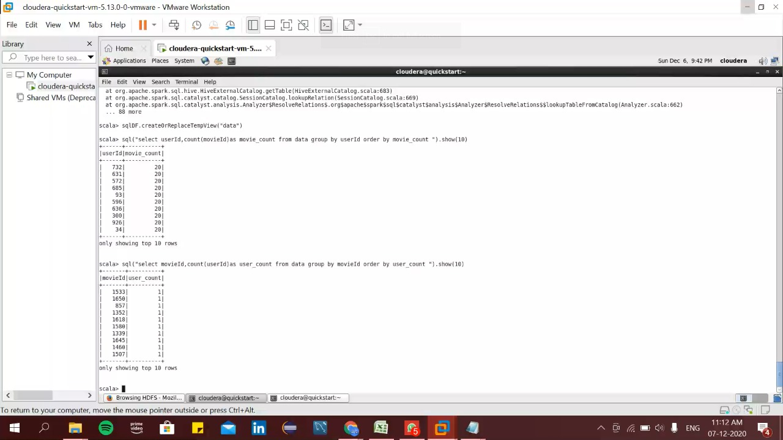

We have done SQL query to get the count of users who watched a particular movie:

sql("select movieId, count(userId) as user_count from data group by movieId order by user_count ").show(10)

Creating table u-user and get the view:

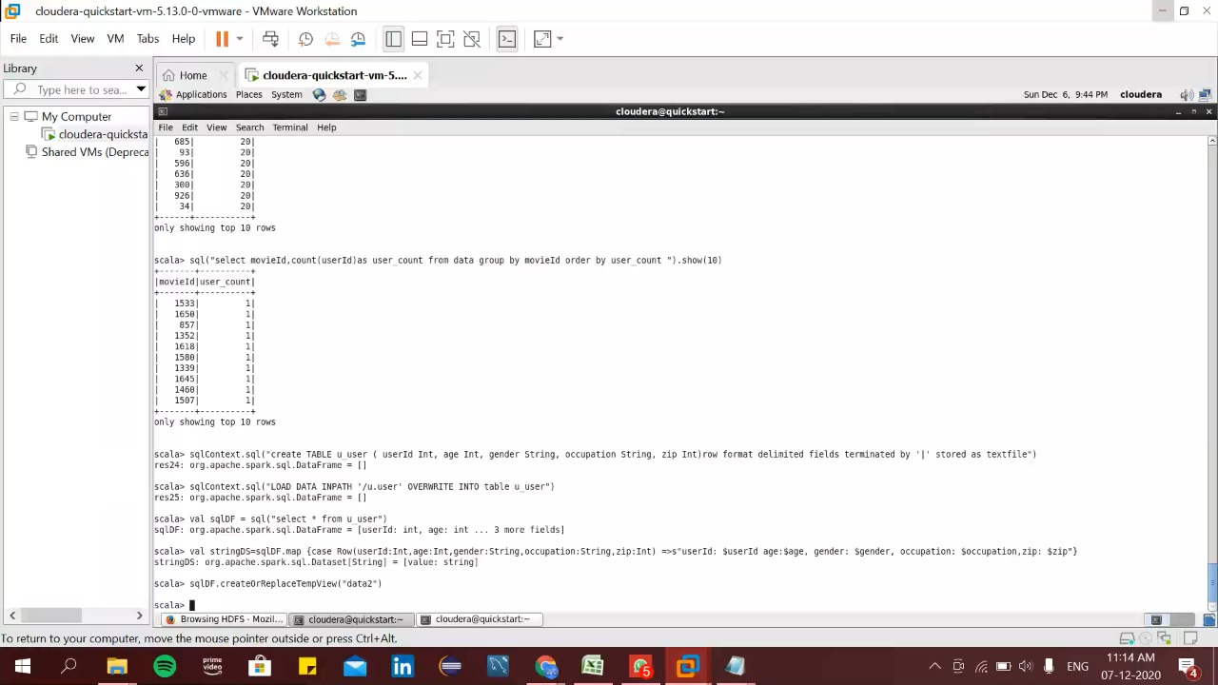

Now we have to create another table for u_user csv .The steps are same as we have created at above.

sqlContext.sql("create TABLE u_user ( userId Int, age Int, gender String, occupation String, zip Int)row format delimited fields terminated by '|' stored as textfile")

sqlContext.sql("LOAD DATA INPATH '/u.user' OVERWRITE INTO table u_user")

val sqlDF = sql("select * from u_user")

val stringDS=sqlDF.map {case Row(userId:Int,age:Int,gender:String,occupation:String,zip:Int) =>s"userId: $userId age:$age, gender: $gender, occupation: $occupation,zip: $zip"}

sqlDF.createOrReplaceTempView("data2")

Grouping based on gender of u_user:

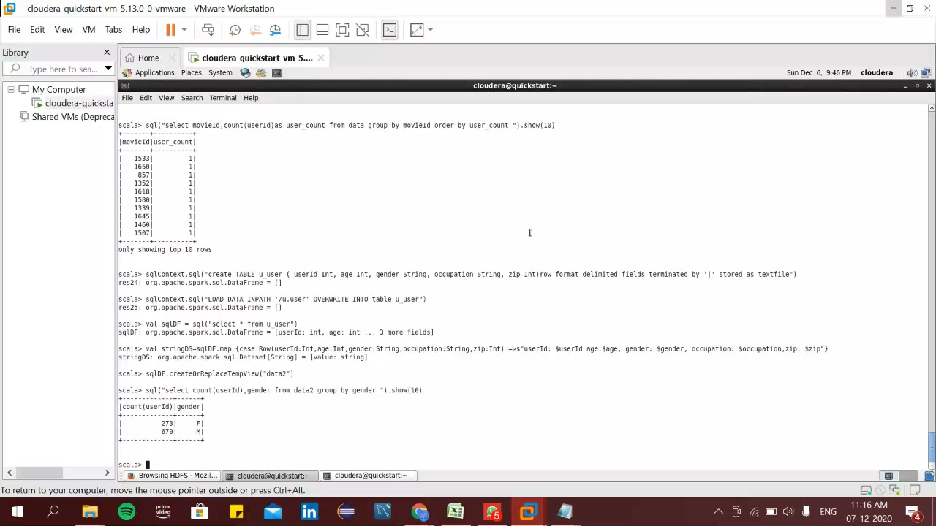

Display the total number of males and females using:

sql("select count(userId),gender from data2 group by gender ").show(10)

Joining two tables based on id:

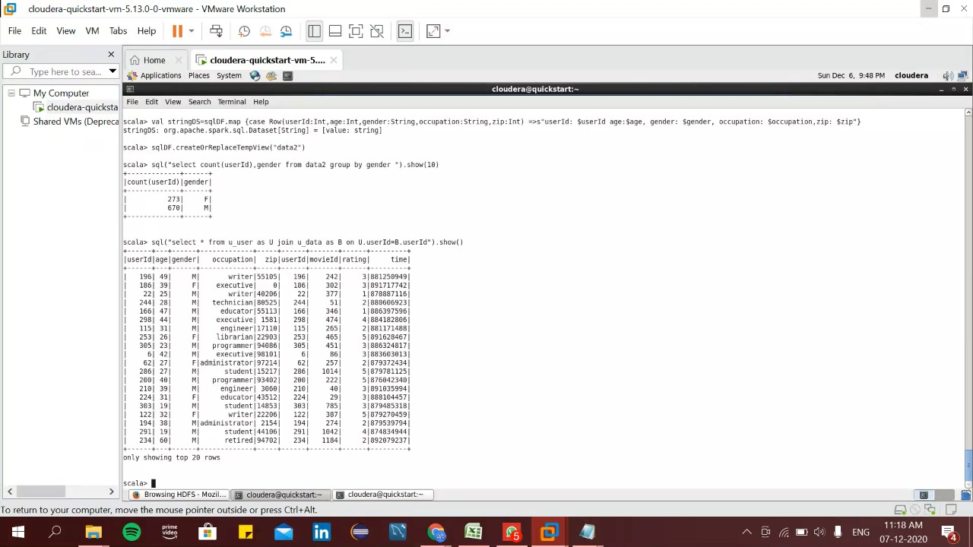

We have done a joining of the two tables we have created and displayed the result.

sql("select * from u_user as U join u_data as B on U.userId=B.userId").show()